***Workshop on Biotrophy and Plant Immunity 7th & 8th of April 2022***

**Organizational notes**

**for attendees with hotel accommodation at:**

**BrauHotel Bonn  
Address: Brüdergasse 6, 53111 Bonn**

**Phone:** [**+49 178 79 03 403**](tel:00491787903403)

**Check-in:**  6th of April // 2pm – 11pm

**Check out:** 9th of April // 11am

**Covid19 regulation:** Currently 3G: (vaccinated, recovered or daily negative test.

(Antigen, not older than 24h; PCR, not older than 48h)

**Breakfast:** **Please be aware that we have booked the rooms without breakfast. We have organized breakfast for you at the event location starting at 8.00 a.m.**

**Travelling:** Due to the difficult parking situation in Bonn, we recommend to travel by public transport, where possible.

**Event location:** Universitätsclub Bonn e.V.

Konviktstr. 9

53113 Bonn

(Bus station: **Brüdergasse/Bertha-von-Suttner-Platz**)

**Link for finding**

**bus connections:** https://www.swb-busundbahn.de/fahrplaene/fahrplanauskunft/

**Parking information for attendees arriving by car**

If you don´t find a free parking area at the Hostel45 you can hold on for a moment in front of

the Hostel, bring the luggage into the Hostel and park your car afterwards at the:

***Parking garage* Operparkgarage: Brassertufer, 53111 Bonn (distance450 meter from the hostel).**

[Google Maps route find here-](https://www.google.com/maps/dir/Operngarage,+Brassertufer,+53111+Bonn/BrauHotel+Bonn,+Br%C3%BCdergasse,+Bonn/@50.7366696,7.1028592,17z/data=!3m1!4b1!4m14!4m13!1m5!1m1!1s0x47bee19f35f1096d:0xa0fdb27b9a93e829!2m2!1d7.1070124!2d50.7375992!1m5!1m1!1s0x47bee1a07b140001:0x79e6500133372424!2m2!1d7.1026252!2d50.7358931!3e2?hl=de-DE)

**Tickets for the garage are 30 Euro for 3 days (3x24 hours) and please follow these instructions to get**

**the ticket if needed**

The products can be purchased exclusively at pay station no. 9.2 (lower parking deck,

left pay station) and only by card payment (GiroCard and credit card).

After you have parked your car in the „Operngarage“, please insert the parking ticket you took out when you entered the garage into the parking ticket slot of pay station no. 9.2 (lower parking deck, left pay station).

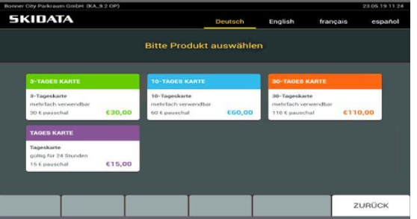

Please select the product you need by pressing a button or by touching the touch screen. Please pay the displayed amount by card payment (GiroCard and credit card).

**Unfortunately, cash payment is not possible.**

During the booked period you have the possibility to leave the car park with the already paid ticket and enter again. For this purpose the paid parking ticket will be issued again by the pay station. The parking ticket must then be inserted into the respective ticket issuer or ticket taker when entering and exiting the parking garage. The barrier opens and the ticket is reissued for further use.

**Hotel direction from the hotel to the event location University Club Bonn**

**BrauhotelBonn:** (just a walk of ca. 10 Minutes – google maps link below)

[Google Maps route find here-](https://www.google.com/maps/dir/BrauHotel+Bonn,+Br%C3%BCdergasse+6,+53111+Bonn/Universit%C3%A4tsclub+Bonn+e.+V.,+Konviktstra%C3%9Fe,+Bonn/@50.7352278,7.1023175,17z/data=!3m1!4b1!4m14!4m13!1m5!1m1!1s0x47bee1a07b140001:0x79e6500133372424!2m2!1d7.1026252!2d50.7358931!1m5!1m1!1s0x47bee110c52c1c4f:0x84ce659283c34762!2m2!1d7.1065842!2d50.7352538!3e2?hl=de-DE)

**We are very pleased to welcome you in Bonn!**